Nano Object of the Day

Optical digital recording disks.

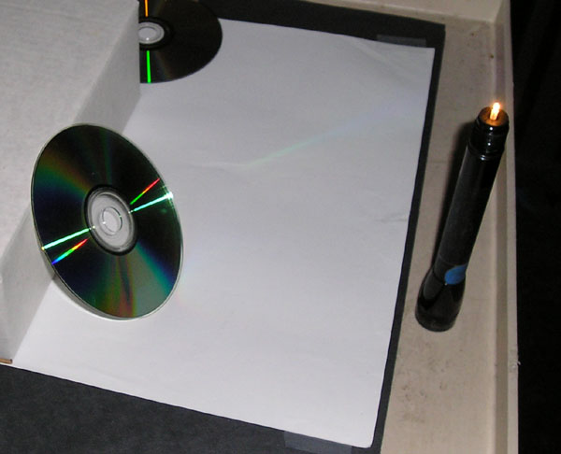
The spectrum of a point of light is shown reflected in a compact disk.

Introduction

Compact disks, DVDs, and Blu-ray disks use pits that have dimensions measured in nanometers to record the 1s and 0s of binary numbers used to represent data.

Material

A CD, DVD and Blu-ray disk (preferably single layer recordable disks)
A minimag light or other point light source.

To Do and Notice

Look at the reflection of the point of light in the shiny surface of each disk.

Notice that a short line spectrum is reflected in the CD,
a longer line spectrum in the DVD,
and that you have to look along a line that just skims the surface of the Blu-ray disk to see one color of the spectrum at a time.

Each disk has a spiral of pits. The spacing of the lines of the spirals are shown in the image below.

Each disk acts like a diffraction grating. The shorter the distance between the lines of pts the broader the spread of the spectrum.

Etc.

Blu-ray Disc uses a "blue" laser, operating at a wavelength of 405 nm, to read and write data. The diodes are GaN (gallium nitride) lasers that produce 405 nm photons directly, that is, without frequency doubling or other nonlinear optical mechanisms.[57] Conventional DVDs and CDs use red and near-infrared lasers, at 650 nm and 780 nm, respectively.

Blu-ray Disc, the spot size is 580 nm

